Vertex – point has 3d coordinates (We get it from wrl or blender file)
Vertices – collection of vertex
Face – its collection of 3-4-more vertex. It contains only indexes of vertex from Vertices (We get it from wrl or blender file)
Faces – collection of face
Slice – collection of vertex which is located in junction of two segments of object. It is not face.
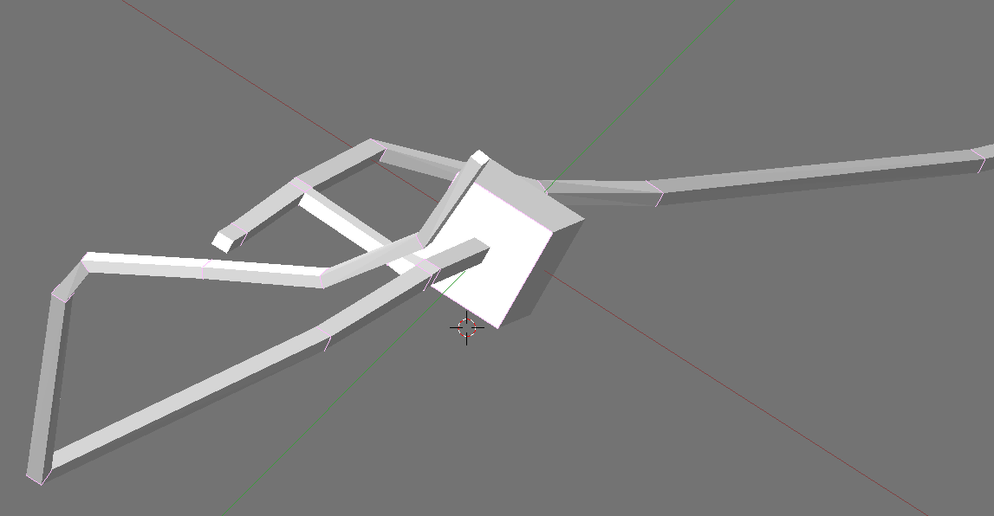
Segment1
Segment2
Slice
Soma

Fig.1

Resulting_point – its center of mass of slice.

1. First step of algorithm we need find start point it means we need find some point located in soma.
What soma is, in Fig.1, obvious its segment with slice which has maximum perimeter (see Fig2).
Soma
Slice1
Axon
Slice2
Start center point
New center point

Fig. 2
2. Algorithm of finding all resulting points
Add current center point to resulting_points collection.
Fill up collection vector_len which contains object with index of vertex from vertices collection and distance from this point to current center point
Step 1. iteration = 0
Find for current center point nearest slice (find nearest slice from vector_len of the points). Count center point for finding slice (put verities of this slice to checked point collection) and current center point = center point. Then iteration += 1 and we run this recursively with new center point.
iteration != 0
Find next center point.
- If in input arguments _slice = None we initialize slice from vector_len collection. Else _slice != None => slice = _slice
- Find adjacent point for all point from slice. Adjacent point collection contains only that point which don’t contain in checked points collection
slice
Adjacent point collection
Axon

Soma

Fig. 3
- Adjacent point collection can have 4, 6, 8 or more points.
  - If it has 4 point it means that it simple segment without any brunching. In this case we find slice from this 4 adjacent point collection find new center point. Current center point = new center point, iteration += 1, put verities of this slice to checked point collection, then we go to Step 1.
  - If it has 6 point.
    - If input argument isBrunchStart = false it means that is brunching segment. This two slices Slice1 and Slice2 are founded by analyzing adjacent points.
    - After we find center point for this two slice and go to Step 1 for every new center points, put verities of this slices to checked point collection

slice
Slice2
Slice1

Fig. 4
- If input argument isBrunchStart = true. It means that we located in firs t segment after brunching. In this case we create slice from adjacent points and find center point for it, put verities of this slices to checked point collection. Current center point = new center point go to Step 1 for this.
  - If It has 8 points.
    - Trying to find two slices. Slice1 and Slice2 from adjacent points

Slice1

Slice2
slice

Fig. 5
- If we find 2 slices => count center point for each, put verities of this slices to checked point collection and go to Step 1 for every new center point.
- If we find 0 slice It means that we located in first point of axon or dendrite. In this case we select that slice perimeter of which has a less value, count new center point, put verities of this slices to checked point collection and go to Step 1 for every new center point.
Soma
slice
Adjacent point
Adjacent point

Fig. 6
Step 2.
If iteration = 1
Need to check if Soma has any other dendrites. Check 5 nearest to start center point slices if we find it. If we find such slice then we go to step 1 with new current center point (count from this slice).

